

Technical Documentation

Svm Dr - Resync

nov 2018

*Number of pages : 6*

*Version : 1.0.1*

# Document Information

## Revision History

|  |  |  |  |  |
| --- | --- | --- | --- | --- |
| Date | Version | Status | Prepared by | Comments |
| 2017-09-01 | 1.0 | Draft | WFA | Initial Draft |
|  |  |  |  |  |
|  |  |  |  |  |
|  |  |  |  |  |

## Document Control

|  |  |  |  |
| --- | --- | --- | --- |
| Role | Name | E-mail | Telephone |
|  |  |  |  |
|  |  |  |  |
|  |  |  |  |

## Approval

|  |  |  |  |
| --- | --- | --- | --- |
| Role | Name | Signature | Sign-off Date |
|  |  |  |  |
|  |  |  |  |
|  |  |  |  |
|  |  |  |  |

## Table of Contents

Svm Dr - Resync 1

nov 2018 1

*Number of pages : 6* 1

*Version : 1.0.1* 1

Document Information 2

Revision History 2

Document Control 2

Approval 2

Table of Contents 3

1 Introduction 4

1.1 Purpose 4

1.2 Description 4

1.3 Assumptions 4

2 Workflow Inputs and outputs 4

2.1 Screenshot 4

2.2 Workflow inputs 5

2.3 Workflow outputs 5

3 Workflow operation 5

3.1 Workflow commands 5

4 Apendix 6

4.1 Workflow versions 6

# Introduction

## Purpose

This document defines the operation of the workflow, input parameters and performed tasks.

## Description

Recyncs the snapmirrors of an existing Svm Dr relation.  
Use the option "reverse" to reverse the relations

## Assumptions

For individuals reading this document please note that the following has been assumed:

* A familiarity with NetApp products and technologies
* WFA configuration and NAS system configuration meets requisites and configuration defined in the documents "Storage Engineering WFA Standards" and "Storage Engineering WFA NAS Provisioning and amendments Standards"

# Workflow Inputs and outputs

## Screenshot

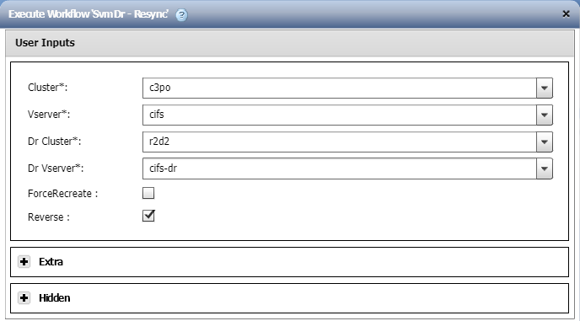

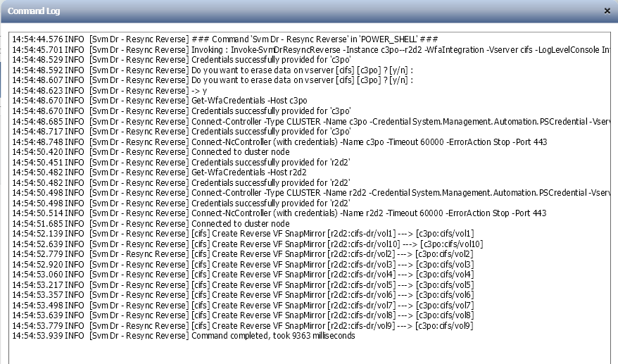

## Workflow inputs

The table below shows the general workflow inputs.

|  |  |  |  |
| --- | --- | --- | --- |
| Name | Type | Description | Notes |
| Cluster | Query |  | Mandatory. |
| Vserver | Query |  | Mandatory. |
| Dr Cluster | Query |  | Mandatory. |
| Dr Vserver | Query |  | Mandatory. |
| ForceRecreate | Boolean |  |  |
| Reverse | Boolean |  |  |
| Debug | Boolean |  |  |
| Dr Suffix | Query |  | Mandatory. |

## Workflow outputs

None.

# Workflow operation

## Workflow commands

The table below shows the commands used in the workflow.

Not all the commands may run in every execution. There are conditionals that may disable a set of commands if conditions are met.

|  |  |  |
| --- | --- | --- |
| Name | Base command | Description |
| Search or define | Search or define / 1.0.0 | This is an empty command used for search or define step in the designer. |
| Svm Dr - Resync | Svm Dr - Resync / 1.0.0 | Resyncs Svm Dr relations Will try to re-establisch the snapmirrors relations If needed, a force recreate is possible |
| Svm Dr - Resync Reverse | Svm Dr - Resync Reverse / 1.0.0 | Resyncs Svm Dr relations in the opposite direction (destination -> source) Will try to re-establisch the snapmirrors relations If needed, a force recreate is possible |

# Apendix

## Workflow versions

|  |  |
| --- | --- |
| Version | Comments |
| 1.0.0 | Initial version |
| 1.0.1 | Remove config file |